P14_RockPaperScissors

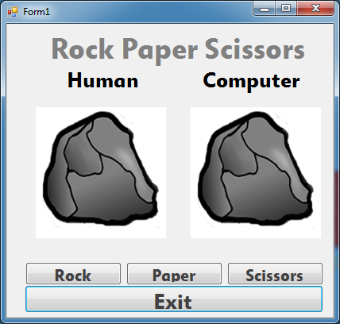

Public Class Form1

Private Sub btnRock_Click(sender As System.Object, e As System.EventArgs) Handles btnRock.Click

picHuman.Image = picFace1.Image

Dim c1 As Integer = Rnd() * 3 + 1

Dim c2 As Integer = Rnd() * 3 + 1

Dim c3 As Integer = Rnd() * 3 + 1

Dim c4 As Integer = Rnd() * 3 + 1

Dim c5 As Integer = Rnd() * 3 + 1

'Rock'

If c1 = 1 Then picComputer.Image = picFace1.Image

If c1 = 2 Then picComputer.Image = picFace2.Image

If c1 = 3 Then picComputer.Image = picFace3.Image

End Sub

Private Sub btnPaper_Click(sender As System.Object, e As System.EventArgs) Handles btnPaper.Click

picHuman.Image = picFace2.Image

Dim c1 As Integer = Rnd() * 3 + 1

Dim c2 As Integer = Rnd() * 3 + 1

Dim c3 As Integer = Rnd() * 3 + 1

Dim c4 As Integer = Rnd() * 3 + 1

Dim c5 As Integer = Rnd() * 3 + 1

'Paper'

If c1 = 1 Then picComputer.Image = picFace1.Image

If c1 = 2 Then picComputer.Image = picFace2.Image

If c1 = 3 Then picComputer.Image = picFace3.Image

End Sub

Private Sub btnScissors_Click(sender As System.Object, e As System.EventArgs) Handles btnScissors.Click

picHuman.Image = picFace3.Image

Dim c1 As Integer = Rnd() * 3 + 1

Dim c2 As Integer = Rnd() * 3 + 1

Dim c3 As Integer = Rnd() * 3 + 1

Dim c4 As Integer = Rnd() * 3 + 1

Dim c5 As Integer = Rnd() * 3 + 1

'Scissors'

If c1 = 1 Then picComputer.Image = picFace1.Image

If c1 = 2 Then picComputer.Image = picFace2.Image

If c1 = 3 Then picComputer.Image = picFace3.Image

End Sub

Private Sub btnExit_Click(sender As System.Object, e As System.EventArgs) Handles btnExit.Click

Application.Exit()

End Sub

End Class